Executive Summary

The 2015 Logistics Consolidated Operational Advisory Group (Log COAG) was held at Whitney Bradley & Brown Inc. Reston (WB&B), VA, from 27-29 October 2015. This executive summary provides the 2014 Log COAG “top” issues (see Figure 1) and a review of this year’s “top” issues. The focus of the 2015 Log COAG was to identify critical issues requiring decisions or resourcing support from Marine Corps senior logistics leadership.

Chaired by the ADC, I&L (LP), the 2015 Log COAG reviewed, discussed, and prioritized outstanding issues as presented by the individual Logistics OAGs. Based on the voting prioritization (see Figure 2), members of the Log COAG further determined those issues that need to be presented to the 2015 MAGTF Logistics Board (MLB) for decision or additional guidance. Outstanding issues that were determined to have no action taken by the MLB were referred back to the respective logistics OAGs for further refinement or resolution.

The Log COAG convenes annually and is intended to be the first event to integrate the year’s Logistics Advocacy efforts, which culminates with the Installations and Logistics Board (ILB). Over the last year, in preparation for the Log COAG, the ten formally chartered Logistics OAGs prepared updates, provided the current status of assigned MCILR/ILB taskers from 2014 and identified “top” issues.

All “top” issues, topics of interest and overall general comments were captured using ThinkTank, a collaborative, web-based information sharing and discussion tool. In addition to providing input, the voting members, annotated below, were able to cast votes for validation and prioritization of “top” issues.

- MARFORPAC G-4
- MARFORCOM G-4
- MARFORRES G-4
- MARFORSOC G-4
- I MEF G-4
- II MEF G-4
- III MEF G-4
- 1ST MARDIV G-4
- 2^{D} MARDIV G-4
- 3^{D} MARDIV G-4
- 4TH MARDIV G-4
- 1ST MAW G-4
- 2^{D} MAW G-4
- 3^{D} MAW G-4
- 4TH MAW G-4
- 1ST MLG G-3
- 2^{D} MLG G-3
- 3^{D} MLG G-3
- 4TH MLG G-3
- MARCORLOGCOM
- OAG Leads

2014 Log COAG / 2015 Log COAG Comparison:
Provided below are the 2014 and 2015 Log COAG voting “waterfall” charts. The 2015 Log COAG was provided the 2014 results for comparison/historical reference as some issues are an enduring effort and were carried over to this year’s Log COAG. Ranking of issues was based on a single yes/no vote by the voting members.
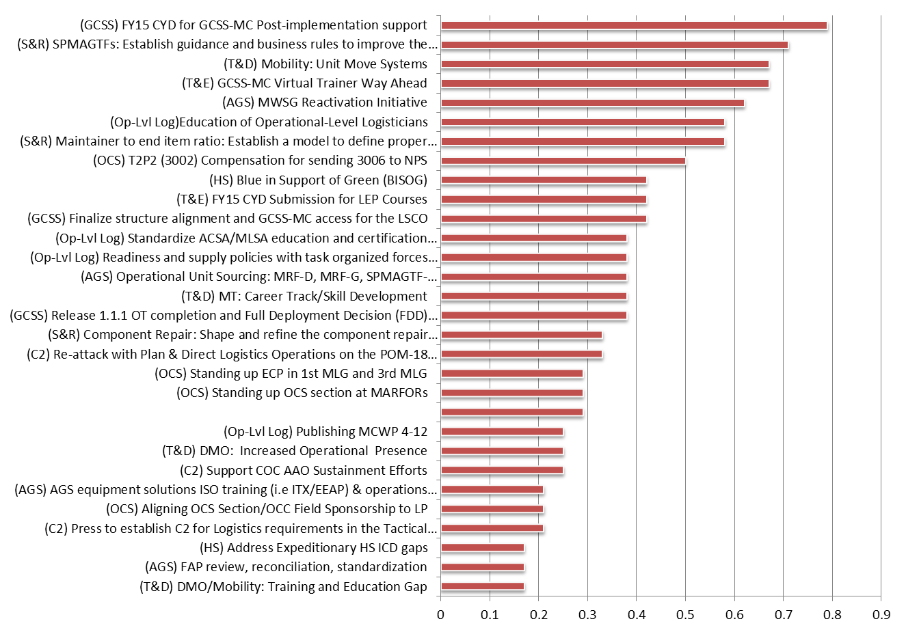
2014 Log COAG

Figure 1. 2014 Log COAG Issues Assessment

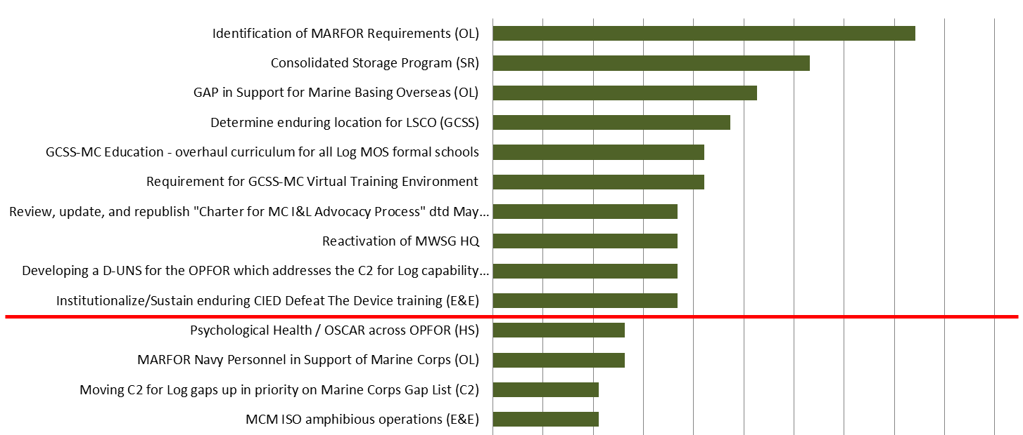
2015 Log COAG

Figure 2. 2015 Log COAG Issues Assessment
2015 Issues for the MLB:
A total of 39 ballot items were identified as issues that required prioritization and discussion. Figure 2 depicts the top half of ballot items with a red “cut off” line. The red line was determined by the voting members to be the “break point” and issues above the line would be submitted for consideration by the MLB.

The “top” issues recommend for decision or resourcing support by the MLB in priority sequence and key comments/observations are as follows:

- Identification of MARFOR Requirements (Operational Level Logistics OAG):
  - Sourcing equipment sets for the SPMAGTF- CR (AF, CENT) is at the core of this issue.
  - Sourcing comes largely from Marine Corps Operating Forces (OPFORs) and a fair amount was excess but certain sourced items (A and E TAMCNs) were not excess and OPFOR units became deficient.
  - Currently equipment sets for the SPMAGTF- CR (AF, CENT) are not “official” sets in that they do not have Approved Acquisition Objectives (AAOs) associated with them as T/Es for OPFOR units. “Now that these SPMAGTF- CRs have been in existence for several years with no end in sight, we need to address the issue of how do we (1) refresh/replace existing equipment and (2) how do we field new equipment?”
  - If the SPMAGTFs are going to be permanent structure, there is a need for an enterprise policy for replacing Equipment Density List (EDL) requirements to include non-rotational equipment.
  - Potentially this could be a working group under the Sustainment Readiness OAG.

- Consolidated Storage Program (CSP) (Sustainment Readiness OAG):
  - Centralized management of equipment challenges our “traditional” battalion and squadron-level accounting framework. CSP centrally manages Individual Combat Equipment (ICE), Special Training Allowance Pool (STAP), Chemical, Biological, Radiological, Nuclear, Explosive (CBRNE), Soft-Walled Shelters and Camouflage Netting.
  - Transitioning sustainment of STAP, CBRNE and SWS&CN to MARFORs for involvement.
  - Currently LOGCOM centrally manages CSP in support of majority of the enterprise, but the entire enterprise is not included in the program.
  - Way ahead is to establish a dedicated funding line for sustainment of all commodities within the CSP (replacement/replenishment) and migration of sustainment responsibilities.

- Gap in support for Marine Basing Overseas (Operational Level Logistics OAG):
  - No advocacy or lead at DC, I&L to support and address MARFOR requirements for deployed forces basing aboard non-USMC installations in both garrison and expeditionary environment. These requirements include military construction (MILCON), renovation requirements, programming for BOS funding responsibilities, and BOS-I designation.
  - Primary issue involves authorities to commit USMC funding for OCONUS (sustainment) locations. Identification and use of sites includes a requirement to maintain. Current bill is paid out of MARFOR OM&MC budgets.
  - Should MCICOM get involved with expeditionary basing requirements?

- Determine enduring location for Logistics Systems Coordination Office (LSCO) (GCSS-MC OAG):
  - The LSCO structure was consolidated in the MLGs.
  - Review the conditions for if/when transition occurs from MLG to MEF.
  - Host a LSCO WG to discuss remaining issues with system access/roles, system access/role training, and R12 upgrade preparation.
  - Initiate staffing actions for MEF transition.
  - Continue to advocate for increased system access for LSCOs.

- GCSS-MC Education – overhaul curriculum for all Log MOS formal schools (GCSS-MC OAG):
  - GCSS-MC was a top issue in 2014 and continues to be a major topic at the Log COAG.
  - The current perception among senior logisticians is that there is a lack of GCSS-MC education/training for all logistics MOSs in our formal schools.
  - What is needed is an immediate and complete review of the curriculum for every logistics course.
  - Course length should be increased to include more hands on practical application.
  - Consider integrating GCSS-MC OAG into the C2 for Logistics OAG.

- Requirement for GCSS-MC Virtual Training Environment (GCSS-MC OAG):
  - “We desperately need a Virtual Training Environment for GCSS-MC!”
  - Potential standalone copy of GCSS-MC existing on a server that Users can reach via the web, worldwide and kept current.
  - Mobile Training Suites expansion into FY15 – 24 / FY16 - 39, but are they are “out-of-date” in that they are behind the current production version of GCSS-MC?

- Review, update, and republish “Charter for MC I&L Advocacy Process” (LPV):
  - Logistics Advocacy Secretariat has for action to update charter.

- Reactivation of MWSG HQ (Aviation Ground Support OAG):
  - This is a joint effort, should this topic be readdressed by DC, I&L and DC, AVN?
  - AGS and ABGD Command and Control requirement exist.
  - Aviation solutions across (DOTMLPF) exist.
  - MROC concurrence, awaiting Decision Memorandum.

- Develop a D-UNS for the OPFOR which addresses the C2 for Log Capability gaps (C2 for Log OAG):
  - Moving C2 for Log gaps up in priority on the Marine Corps Gaps List.
  - Continue to develop D-UNS.
  - Continue to ensure C2 for Logistics requirements are fully integrated into MAGTF C2 initiatives.

- Institutionalize / sustain enduring CIED Defeat The Device Training (Engineer and EOD OAG):
  - Constrained TECOM training funds are in competition and challenging to provide $8-12M in contractor Mobile Training Team (MTT) efforts to conduct adequate MAGTF C-IED DTD training.
  - Continue engagement through C-IED OAG in POM process to ensure funding is institutionalized.

MLB Requested Updates:
As requested by the 2014 MLB, the 2015 MLB will also receive updates on the following initiatives from the Transportation & Distribution OAG.
- Marine Expeditionary Unit (MEU) Distribution Liaison Cell (DLC) Proof of Principle (PoP) Update:
- Improve distribution capability to deployed MEUs by increasing distribution Marines (MOS 31XX) assignments to MEU CE/CLB.
- Quad MLG has current PoP underway and request this initiative be readdressed in the 2016 MLB. QUAD MLG (at behest of 2d MLG) wants the PoP to continue in order to include results from 2 addition MEU trials with differing DLC configurations.

- Maritime Pre-Positioned (MPF) Force Distribution and Accountability Total Asset Visibility (TAV) Gap Analysis:
- The T&D OAG was tasked by the MLB to review the MPF Offload process.
- Different ITV capabilities are being used: IPRIME and Portable Deployment Kits (PDKs).
- Marines (TSB / LFSP, AAOG, etc.) are not adequately trained and equipped to use AIT enablers.

- Motor Transport Study – Center for Naval Analysis (CNA) Update:
- ACMC directed a holistic analysis of motor transport capabilities to address potential imbalances in assets and personnel across supported and supporting commands.
- Dec 2014, DC, I&L and DC, CD&I approved CNA MT structure project proposal.

Conclusion:

All products from the 2015 Log COAG are posted on the Logistics Advocacy SharePoint located at:
https://eis.usmc.mil/sites/HQMCLP/LogisticsAdvocacy/SitePages/Home.aspx

Any questions can be directed to the Logistics Advocacy Secretariat at (703) 695-6101.

